

**SUMINTRA FIBRE AND DECOR PVT LTD**

**CIN: U74999JH2018PTC010918**

**GSTIN: 20AAZCS7597Q1Z0**

**Registered Office**: Plot No. 6902,Kunwar singh Colony,Chas,Bokaro,Jharkhand – 827013.

**Works at**: Plot no.: G1/G2/G3, BIADA, Phase- IV, Bokaro, Jharkhand - 827014

**Tel:** +919319844480/+917257905826

**E-Mail**: [info@saturnfibre.co.in](mailto:info@saturnfibre.co.in); [info@saturnfibre.com](mailto:info@saturnfibre.com)

[**https://www.indiamart.com/saturnfibre/**](https://www.indiamart.com/saturnfibre/)

**TECHNO COMMERCIAL PROPOSAL**

**OF**

**CUSTOMIZED PREFAB HOUSE PANEL BASED**

For

SURJIT PAL,

kolkata.

**SECTION: 1.1 (DESIGN)**

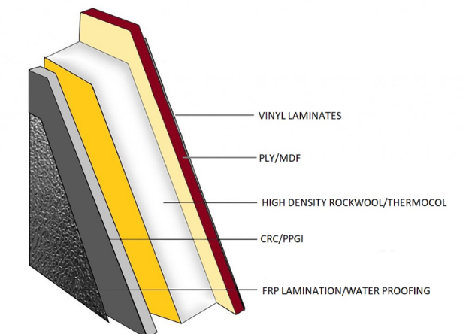

FLOOR

WALL PANEL

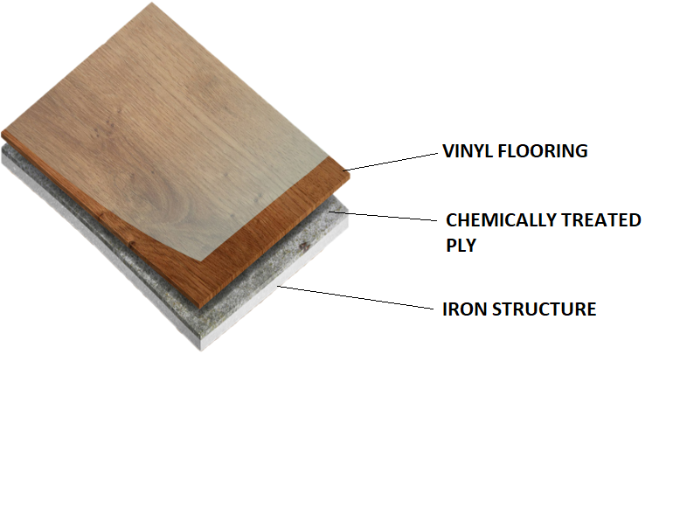

TOILET/BATH FLOOR

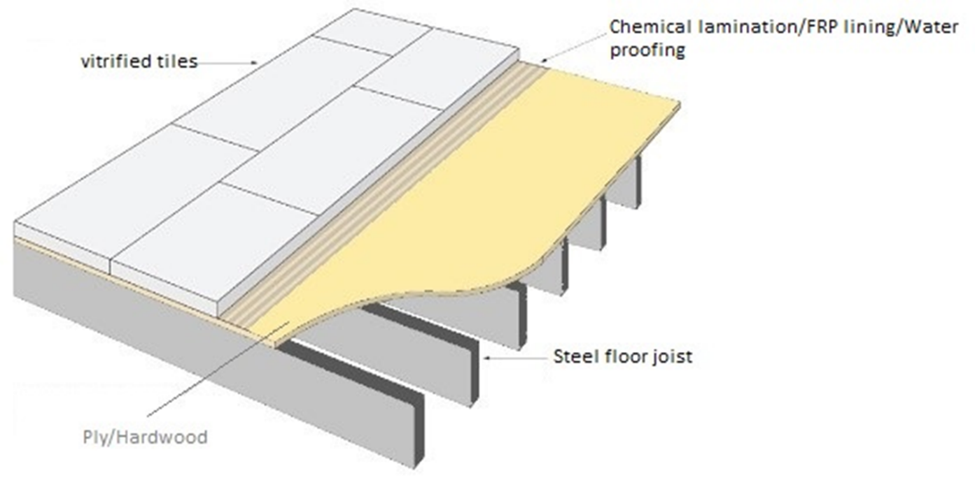

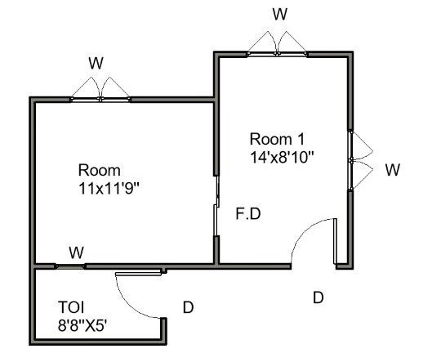

**\*\*Only for reference >> A TYPICAL PANEL BASED PREFAB HOUSE INTERIOR & EXTERIOR LOOK**

**SECTION: 1 .2 (SPECIFICATIONS)**

|  |  |  |  |
| --- | --- | --- | --- |
| S.NO. | PARTICULARS | PREFAB HOUSE-PANEL BASED | |
| 1 | DIMENSION | L20’XW19'XH10'(CEILING) | |
| 1.1 | Length | 20 | ft |
| 1.2 | Width | 19 | ft |
| 1.3 | Height (Ceiling) | 10 | ft |
| 1.4 | Surface Area (Peripheral including ceiling) | 1556 | sqft |
| 1.5 | Room 1(14’x8’10’’) | 1 | Nos |
| 1.6 | Room 2 (11’x11’9’’) | 1 | Nos |
| 1.7 | Toilet (8’8’’x5’) | 1 | Nos |
| 2.3 | Stair case (3'x7') inside approach to hanging bed with base 8'x8' in air 5.5' above floor | 0 | Nos |
| 2.4 | Wall thickness | 100 | MM |
| 2 | Type Of Cabin | PREFAB HOUSE | |
| 3 | Features | Can be assembled at site | |
| 4 | Capacity | FAMILY |  |
| 5 | Production Time | 20 | days |
| 6 | Installation time (Max) | 7days | |
| 7 | Total Built Up Area (Sqft) | 289 | |
| 8 | Shape of built up land | Rectangular | |
| 9 | GENERIC INFORMATION | SIZE | QUANTITY(Nos.) |
| 9.1 | WINDOWS | 4'x4' std. | 3 |
| 5'x6.5'(French) | 0 |
| 2'x2' | 1 |
| 9.2 | DOORS | 6.5'X5'(French) | 1 |
| 6'x6'(French) | 0 |
| 6.5'X3.15'std. | 1 |
| 6.5'x2.5' toilet std | 1 |
| 6.5'x6'(Sliding-kitchen) | 0 |
| 9.3 | Weather Guard - Windows(exterior) | L4' | 0 |
| L5'' | 0 |
| 9.4 | Weather Guard - Doors(exterior) | L10' | 0 |
| L5' | 0 |
| 9.5 | Metal Door | 10'x12' | 0 |
| 10.00 | MATERIAL SPECIFICATION | REMARKS | |
| 10.1 | INSULATION OF WALL/ROOF | One piece insulation core with rockwool 75MM thick | |
| 10.2 | SIDE WALL PANEL | External face wall CR 0.40MM and internal face of wall 12.0MM thick Ply single side laminated with 50MM thick high density Rockwool sandwich. | |
| 10.3 | WINDOW PANEL | Powder coated Aluminium sliding windows with 4MM tinted glass, mosquito net and grill as per standard | |
| 10.4 | CEILING | 12.00 MM Ply single side laminated bottom | |
| 10.5 | ROOF | 0.45 MM PPGI sloped either side | |
| 10.6 | FLOOR (Bedroom, hall and walkway) | 18MM Thick water proof, termite proof hard wood/ply based on M.S angle frame. PVC flooring on top | |
| 10.7 | FLOOR (Toilet &Bath) | Vitrified tiles on top of FRP laminated 18.00 MM thick waterproof hardwood/ply fixed on M.S angle frame | |
| 10.8 | OUTER PERIPHERY FRAME | SHS 100X100X4MM | |
| 10.9 | JOIST BEAM | SHS 80X80X4MM | |
| 10.10 | INTERIOR JOIST BEAM | NA | |
| 10.11 | PANEL FRAME | NA | |
| 11.0 | OTHER OFFERINGS | | Quantity(Nos.) |
| 11.1 | Kitchen slab | Standard(L6'xW2') | 0 |
| 11.2 | Hanging bed base - customer's design | 8'x8' | 0 |
| 11.3 | stair for hanging bed approach-customer's design | 3'x7' | 0 |
| 12 | POWER SOURCE | OPTIONS | YES/NO |
| 240Volt,50HZ AC power supply | EXTERNAL | Y |
| INBUILT SOLAR POWER SYSTEM | NA |
| 13 | SANITARY | ITEMS | QUANTITY |
| Sanitary plumbing with PVC pipes and S.S fittings except geyser line (with GI pipe). | WESTERN COMODE (CERAMIC) | 1 |
| MIRROR IN BATHROOM | 1 |
| FLUSH TANK (PVC) | 1 |
| WASHBASINS (CERAMIC) | 1 |
| URINALS (CERAMIC) | 0 |
| KITCHEN SINK(STEEL) | 1 |
| SHOWER HEAD (S.S) | 1 |
| WATER SPREADER FOR WC | 1 |
| Provision for geyser 15Ltr for bath common | 1 |
| 14 | SOURCE OF WATER | OPTIONS | YES/NO |
| Water inlet point for fresh water from external source or overhead tank will be provided.Outlet for used water and no sewage provision. | EXTERNAL | Y |
| OVERHEAD TANK 1000Ltr | NA |
| OVERHEAD TANK 500Ltr | NA |
| 15 | ELECTRICAL | ITEMS | QUANTITY |
| All wirings will be concealed with PVC insulated copper wires of RR Kabel,Earth wire for safety | CEILING FAN - CROMPTON AURA | 0 |
| 5AMP ANCHOR SWITCH AND SOCKET | 0 |
| 15AMP ANCHOR SWITCH AND SOCKET | 0 |
| SYSKA LED TUBE LIGHT T5-18W 4FT | 0 |
| SYSKA LED Light 9W BULB | 0 |
| CROMPTON GREAVES 150-200MM EXHAUST FAN | 0 |
| AIR CONDITIONER (WINDOW) PROVISION | 0 |
| AIR CONDITIONER (SPLIT) PROVISION 1.5 Ton | 0 |
| AIR CONDITIONER (SPLIT) PROVISION 1.0 Ton | 0 |
| GEYSER - 15LTR COMMON FOR TWO TOILET | 0 |
| MODULAR SWITCH BOARD | 0 |
| CHARGING POINT | 0 |
| 16 | LOCKING/SECURITY | Provision of locking door and windows grill to prevent unwanted provision | |
| 17 | INSTALLTION AND FIXING | On terrace | With rivet fasteners on M.S plate to the floor |
| At ground | NA |
| Cement platform | YES |
| 18 | COLOUR | Two coats of synthetic enamel paint and PU coated (Weather proof) on expose structure of all M.S items on top of red oxide antirust coating | |
| 19 | QUALITY CERTIFICATION | ISO 9001-2015 QMS | |
| EN 1176: 2017 CERTIFIED | |

**SECTION: 3 (PRICING)**

|  |  |  |
| --- | --- | --- |
| **S.NO.** | **Detail** | **Price** |
| 1 | Unit cost | |  | | --- | | 627,250.00 | |
| 2 | Transportation (From Factory to Dhanbad) | 20,000.00/- |
| 3 | Total | 647,250.00/- |
| 4 | GST (18%) | 116,505.00/- |
| 5 | Grand Total | 763,755.00/- |
| In Words: Seven Lakh Sixty Three Thousand Seven hundred Fifty Five Rupees. | | |

**TAXES & DUTIES**

1. The current offer is based on the applicable GST@ 18.00 %. Any statutory change in taxation applicable at the time of supply/ execution during the currency of contract shall be on customer's account.

2. Freight to site is included in the above price.

3. Unloading of the building & construction is considered in the above price

4. Cost of installation included in above price

**SECTION: 4 TERMS OF PAYMENT**

**Supply Payment Terms**: (SUMINTRA FIBRE AND DÉCOR PRIVATE LTD)

1. 60% along with PO or confirmation through mail.
2. 35% on delivery of materials on site.
3. 5% after successful installation.

**Installation Terms:** (SUMINTRA FIBRE AND DÉCOR PRIVATE LTD)

1. After receipt of 95% of payment as per term.

**SECTION: 5 BANK DETAIL**

|  |  |  |  |
| --- | --- | --- | --- |
| S.no. | Name | **SUMINTRA FIBRE AND DÉCOR PVT LTD** | **SUMINTRA FIBRE AND DÉCOR PVT LTD** |
| 1 | PAN Number | AAZCS7597Q | AAZCS7597Q |
| 2 | Name of the Bank | **UCO BANK** | **HDFC BANK** |
| 3 | Address of the branch | B-13,City Centre,Sector IV,Bokaro steel city,Jharkhand-827004 | B-9,City Centre,Sector IV,Bokaro Steel City,Bokaro,Jharkhand-827004 |
| 4 | Branch Name | Bokaro steel city-Ranchi | Bokaro Steel City |
| 5 | Branch code | 0243 | 0267 |
| 6 | RTGS/NEFT IFSC CODE | **UCBA0000243** | **HDFC0000267** |
| 7 | Type of Account | CA | CA |
| 8 | Account Number | **02430210001431** | **50200052481302** |
| 9 | Branch Email ID | [bokaro@ucobank.co.in](mailto:bokaro@ucobank.co.in) | [support@hdfcbank.com](mailto:support@hdfcbank.com) |

**SECTION 6: DELIVERY**

1 : For order confirmation

a. Issue of Purchase Order or email confirmation

b. Advance payment as per terms under **SECTION 4.**

c. Signed Proposal contract copy, whichever is the Later.

2 : **Supply + Installation**: Total supply and installation shall be completed **within 4 weeks** from the date of receipt of P.O or Advance payment whichever is later.

**SECTION 6: EXCLUSIONS**

1. Anything other than what is mentioned by us in this offer

**SECTION 7: VENDOR LIST**

|  |  |  |  |
| --- | --- | --- | --- |
| Sl. No | DESCRIPTION | IMPORTED/LOCAL | BRAND MAKE/COMPANY NAME |
| 1 | M.S PIPE & STRUCTURE | Local | SAIL/TATA/JINDAL/BHUSHAN/ISPAT |
| 2 | PPGI /CRC | Local | SAIL/TATA/JINDAL/BHUSHAN/ISPAT |
| 3 | PLY BOARD | Local | CENTURY/GREENPLY/MAYUR |
| 4 | GLASSWOOL/ROCKWOOL | Local | ROCKWOOL INDIA |
| 5 | PAINT | Local | ASIAN/BERGER/SHALIMAR/NEROLAC |

**SECTION 8: CLIENT’S SCOPE**

1. Necessary approval required to work at site.
2. All civil works related to foundation or ground preparation at site
3. Anything extra not listed in our scope.

**SECTION 9: DISCLAIMER**

This document is strictly confidential communication to and solely for the use of the recipient and may not be reproduced or circulated without SFDPL’s prior written consent.

If you are not intended recipient, you may not disclose or use the information in this documentation in any way.

**SECTION 10: FORCE MAJEURE**

If, by reason of any cause beyond the reasonable control of either party hereto, including, but not limited to, strikes, fire, hurricane, flood, pandemic or other acts of nature or acts of God, Accident, war, acts of terrorism, civil unrest, embargo or other governmental act, regulation or request, or other legal restrictions, such party is delayed in its performance, in whole or in part, of its obligations under this agreement (other than monetary obligation),then such party shall be excused from such performance and such nonperformance will not make the party liable to the other party. The party delayed shall, as promptly, as reasonably possible, notify the other party of the reasons for the delay and its estimated duration.

**SECTION 11: LEGAL JURISDICTION**

All legal issue is subject to BOKARO, JHARKHAND jurisdiction.

**SECTION 12: ACCEPTANCE**

Client’s signature and remarks:

Supplier’s signature and seal: